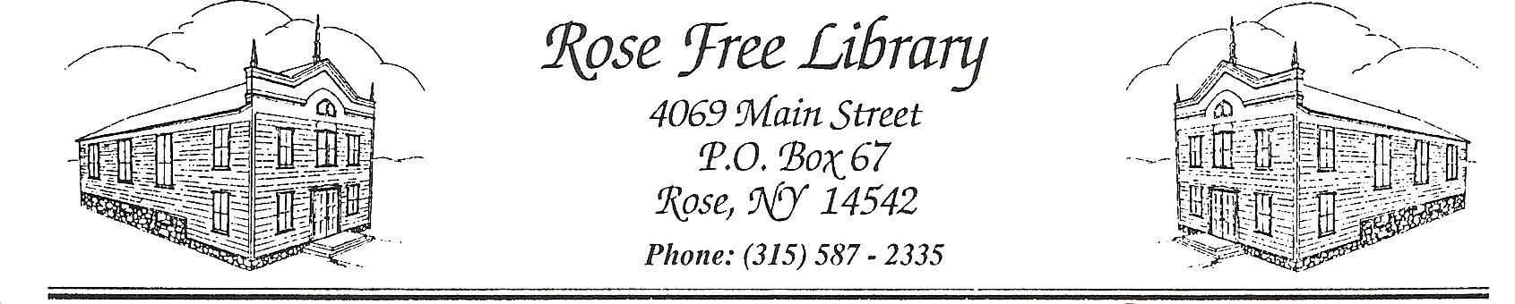 Rose Free Library

April, 2025

Dear Friends of the Library,

National Library Week is April 6-12, and the theme for this year is "Drawn to the Library"! As friends of the Rose Free Library, we know you are drawn to our library in many ways. Many patrons are drawn in to our collections, our activities, and our computer resources. Our younger patrons are often drawn in to our activities, summer reading programs and projects. Whatever draws you in, the Rose Free Library has something for everyone.

Our librarian, Deanna Davis Wiltsie, our clerk, Jolynn MacNabb, and part time clerks and volunteers have continued to work hard to make our library one that draws in the members of our community. In 2024, our Patrons Computer Area underwent significant enhancements, including the installation of new, high-quality desks with plugin features and adjustable standing capabilities. Additionally, the computer chairs have been replaced, giving the area a refreshed appearance. A large, movable whiteboard was purchased to facilitate program activities and promote library events and meetings. As a cost-effective alternative, the library purchased a BLUEY costume for one of our summer reading events, rather than hiring a BLUEY entertainer, which also allowed the costume to be used for future events.

Our summer reading program yielded outstanding results, with 154 participants ranging from infants to adults. Furthermore, we provided the community with 49 STEAM-based activities, along with various additional programs catering to diverse age groups. We are delighted to have collaborated with various Wayne County agencies, clubs, and community businesses throughout the year.

The library has conducted a comprehensive weeding this past year of outdated or non-essential fiction and nonfiction children and adult books. We will continue to revitalize the collection with new, relevant and pertinent books in the years to come. Our Facebook page often features a brief description of new additions to our collection! For additional information, answers to questions, or if you are interested in being a volunteer at the library, or helping in any way, please feel free to contact us! You can visit our Facebook page

(facebook.com/RoseFreeLibrary) or website (roselibrary.org), or when we are open, call us at (315)587-2335.

As always, we are committed to making our library better each year, and the cost of improving our physical space and maintaining and expanding our collections would not be possible without the financial contributions of our community. As we have mentioned in past letters, our shelving needs to be updated, and your donations would help make it possible to purchase new shelving units for our collection. Also, our computers often need upgrades to keep them current and effective. and we are always striving to make sure we can provide other ways to help our community members be drawn to the library. For anyone who feels able and willing to send a tax deductible contribution to our library, it would be greatly appreciated. Checks should be made payable to Rose Free Library and sent to the address above. We are extremely grateful for your past support and for your continued support and understanding as we move forward. We truly hope that you can be part of our adventures here at the Rose Free Library.

Sincerely,

The Board of Trustees

Rose Free Library

President-Jennifer Sutton, Vice President-Cherie Yager, Secretary-Laurie Navratil, Treasurer-Toni Leisenring,

Trustee — Christina Plucinik, Trustee — Lori Peck, Trustee — Heather Luther, Library Director-Deanna Davis-Wiltsie