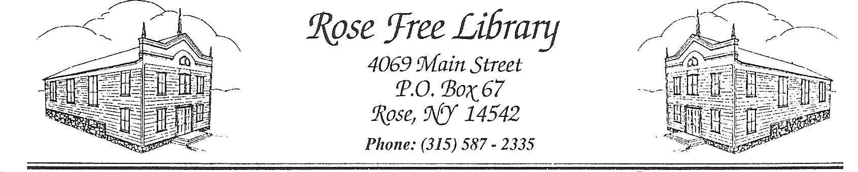

Rose Free Library

**Computer and Internet Use Policy**

1. **Public Access to the Internet**

The Rose Free Public Library provides public access to the Internet as one resource to fulfill the Library’s mission. The Internet expands the scope of information available at the Rose Free Library. It is, however, an unregulated medium that changes constantly and unpredictably. The Library is not responsible for the quality or accuracy of information found on the Internet. Users are responsible for evaluating information received via the Internet.

* 1. **Access to Library Computers**

Parents/guardians are responsible for determining whether their child may use a library computer when completing a library registration card. Parents are encouraged to discuss these safety precautions with their children. Children under the age of 11 must have a parent/guardian sign the computer-use agreement. Parents/guardians of teens ages 11-17 must indicate in writing that they do not wish for their child to have access to library computers. Changes to a patron’s Internet access require the completion of a new registration form.

The OWWL Library System provides content filtering to ensure its libraries are in compliance with the Children’s Internet Protection Act (CIPA).

* 1. **Availability**

Availability of Library computers is on a first-come first served basis and there are no reservations.

If someone is waiting to use a computer, use is limited to 60 minutes per session. Additional 15-minute extensions will be allowed when no one is waiting to use a computer. Youth computers sessions are limited to 90 minutes per day.

All computers will be turned off approximately ten minutes before the Library closes. Please be aware of the time when using the computers.

* 1. **Acceptable Computer Use**

All patrons using the Library’s computers must agree to the Library’s policies and rules governing the use of the Library’s computers. No more than two people are allowed at a single computer at a time; staff reserves the right to deny computer users from using a second chair reserved for a different computer station. Both individuals will be held accountable for any damages or rule infractions.

Users may not make any changes in any program setup or the hard drive configuration. Patrons may save files to a computer but assume responsibility for the content and privacy of said files. Any files saved to the computer will be lost once the computer is shut down at the end of the patron’s session. Library staff is authorized to delete any patron files, including documents, photos, videos, and music files, during routine maintenance of Library computers.

* 1. **Staff Assistance**

Library staff is trained to provide limited support and will assist patrons as time allows.

Only staff members may install new software onto the public access computers as needed by users.

Acceptable software is determined by the staff member. Users should immediately report any problems with equipment to staff.

* 1. **Monitoring**

The Library reserves the right to monitor a patron’s use of a Library computer for compliance with the Computer and Internet Use Policy. If patrons are seen or reported to be viewing potentially offensive or illegal material, as defined under the section 2.2 Illegal Activities, the Library reserves the right to digitally monitor patron use of library computers.

Library staff may produce a screenshot of a Library computer for evidentiary purposes if a Library staff member has a reasonable suspicion that a patron is using the computer in violation of the Computer and Internet Use Policy. Any record of a patron’s use, including a screenshot, shall be retained following the guidelines of our Record Retention and Removal Policy. By accepting the Usage Policy prior to using a Library computer, a patron is consenting to potential monitoring of the patron’s use of the Library computer (including screenshots).

**2.Suspension of Library Privileges**

The user is held responsible for his/her activity on the Internet Persons who do not follow these rules may be prohibited from using computers or other library equipment, have their library privileges suspended, be barred from the Library, and/or be prosecuted for illegal activities.

**2.1 Rights of Users**

The Library’s computers are located in public areas that are shared with Library staff and users of all ages, backgrounds, and sensibilities. Individuals are expected to consider this diversity and respect the rights of others when accessing potentially offensive information or images.

The Internet is not a secure medium and all transactions, files, and communications may be subject to unauthorized access by third parties. It is the Library’s usual practice to erase all customer use records, except those essential for Library business operations. The Library will release records, including those relating to Internet usage, only as required by law.

When a computer session is ended, all information about that session is deleted within the capacity of the Library’s resources. The Library does not, as part of its regular practice, retrieve any information, including websites visited, passwords, credit card numbers, or any other information a customer has entered.

**2.2 Illegal Activities**

Use of the Internet for activities that violate local, state or federal laws is prohibited. This includes, but is not limited to, activities such as viewing child pornography, committing fraud, hacking, unauthorized access, or spreading libel or slander.

Patrons may only make copies allowable by copyright laws or licensed software agreements. Library staff will not assist patrons with the copying or downloading of content protected by copyright law, including but not limited to software, music, movies, and video games. The Library is not responsible for policing patron adherence to copyright laws or software agreements.

**2.Wireless Access**

The Library offers free wireless internet access for use with laptop computers and other wireless devices. The wireless is available during the Library’s normal operating hours. While the Library’s content filtering software applies to wireless usage, the public wireless network is accessible for all ages without restriction.

The Library assumes no responsibility for any alterations or interference with a device’s configuration, operation, or data files resulting from connection to the wireless network. Due to insurance limitations and warranties, Library staff cannot configure patrons’ devices.

Virus and security protection is the user’s responsibility.

The Library assumes no responsibility for damage, theft, or loss of any kind to a user’s equipment, software, data files or other personal property brought into or used at the Library’s facilities.

The Library cannot guarantee that the wireless service will be available at any specific time.

The connection shall not be used for illegal or time-consuming commercial purposes, or for purposes that infringe on other patrons’ access to equal bandwidth.

Patrons shall defend, indemnify, and hold the Rose Free Public Library, its officers, employees, and agents harmless against all claims, actions, and judgments based upon or arising out of the patron’s use of Library wireless connections.

**4. Policy Amendments**

This policy may be amended by the Board of Trustees at any time.

Adopted by the Board of Trustees: 08/20/2020

Amended by the Board of Trustees: 11/18/2024