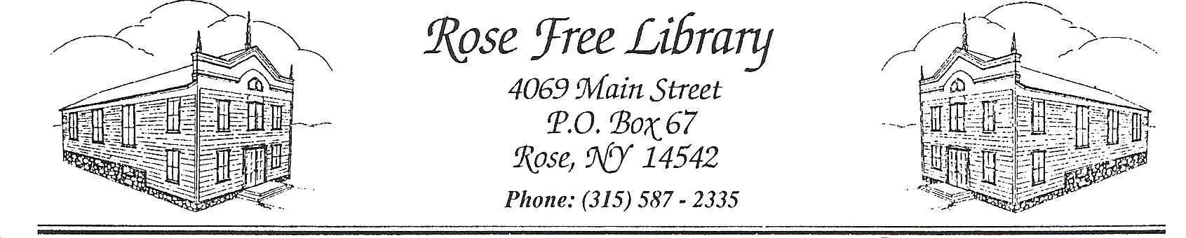

**Procurement Policy**

**Purchasing:**

This policy covers purchases exclusive of items not stated in budget under books, DVDs, office/cleaning supplies and materials that are at the discretion of the director.

Purchases under $300 at the discretion of the library director.

Purchases between $300 and 999.99 the director must consult the board, i.e. purchases of furniture, equipment, etc.

Purchases over $1,000.

Whenever possible, New York State Contract pricing should be used. If state contract is not available:

1. Library director and/or purchasing agent (appointed by the board) creates spec sheet on work or purchase.

2. The library director and/or purchasing agent must make a concerted effort to obtain three written bids. If one of the bids is delayed due to the negligence of the vendor, the Library Director and/or purchasing agent should choose from the two bids obtained.

3. The library director and/or purchasing agent selects one of the three estimates, if available, based on quality, cost and availability (of contractor).

4. The library director and/or purchasing agent brings decision to the board for approval of funds. The project report will briefly reflect estimates received and choice made.

5. All estimates are filed in project folder.

6. The board approves or disapproves.

7. If project is disapproved, the board will advise the next steps.

8. No purchase of goods or services shall be made from any vendor in which elected officials of the library, i.e., the board of trustees, or the library administration, i.e., the library director, hold a full or partial interest, or where a conflict of interest could reasonably be construed.

Receipts and bills must be submitted to Treasurer/bookkeeper.

**Payments from Invoices:**

Invoice payments are made by the Library Treasurer/Bookeeper such as but not limited to Amazon, First Book, Cleaning Services, Phone, Insurance, Demo, OWWL Library System, and O’Haver Financial Services.

Adopted by Board of Trustees on: 10/22/2024