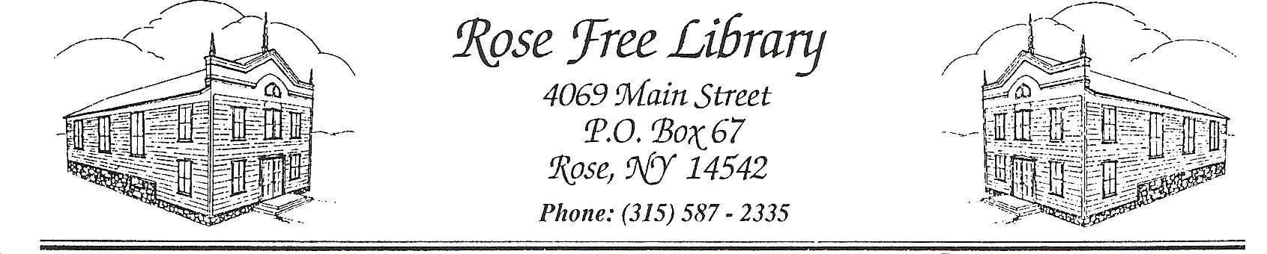

Petty Cash Policy

The Rose Free Library accepts cash and personal checks for payment of library charges (i.e. lost/damaged materials, copying, printing, faxing etc.) and donations.

All payments are recorded on a Daily Record Sheets by category of payment and stored in a locked drawer.

Checks and cash in excess are removed prior to monthly Board of Trustees Meeting. The amounts are recorded by category and the documentation is provided to the Treasurer for deposit at the bank following the meeting.

Deposits are reported to the Board of Trustees in the financial reports presented at the regularly scheduled meeting.

Adopted by the Board of Trustees: 10/22/2024