Amelia Earhart Clothespin Airplanes
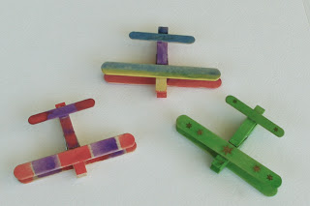

We will build a plane and soar
Over woodland, sea and shore
Over woodland, sea and shore
And fly back to you once more
Simple crafts are a great alternative to screen time and offer a wonderful opportunity for parents and children to learn something new and create something together.
This super simple clothespin and popsicle stick airplane can be made by parents or children and then decorated in myriad colors and patterns with crayons, paint, colored pencils, pens or even strips of tape. Try personalizing each plane with a child’s name or attaching a magnet to the bottom and use it as a handy refrigerator magnet clip!

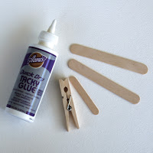
In addition to a clothespin, two large and one small popsicle stick, you will need some kind of glue. Craft glue, white glue or even hot glue all work fine.
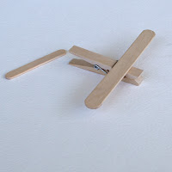
There’s not much to it really. About a half an inch behind the nose (the clipping end of the clothespin) glue one of the larger popsicle sticks to the top of the pin then glue the other directly underneath it on the opposite side.
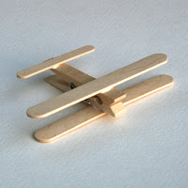
Glue the tail piece about a quarter inch from the tail end of the clip and you’ve got yourself an airplane!
After your plane has dried, decorate or embellish in any way you choose.

