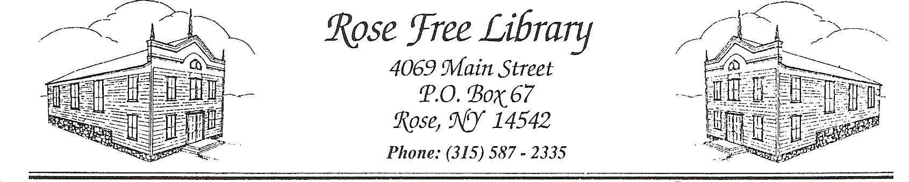
Rose Free Library

Suspension of Patron Access
All Library staff are authorized to suspend library privileges of patrons for up to a week for violations of the Library’s Public Safety Policy, including banning patrons from entering the Library. The Library Director or the Director’s designee is authorized to suspend library privileges of patrons for periods of time longer than a week based on the severity of the violation(s).
Staff must submit a signed and written Incident Report to the Director or his/her designee no later than the next business day whenever a patron’s privileges have been suspended under this policy. The report will, at the least, include the name of the patron, the name of the parent and guardian if the patron is under 18 years of age, the description and date of the incident, and the length of time the patron’s library privileges have been suspended.
In the event that the name of the patron cannot be obtained, the Library may use a photograph of the patron to note and enforce the ban. In such instances, effort will be made to obtain the name of the patron in order to update the records related to the incident and banning.
Notice of the suspension of privileges may be given verbally by staff for suspensions up to a week. In the case of any suspensions, a letter noting the cause and length of the ban will be kept on file with the incident report and any other applicable documents. If necessary, the Library reserves the right to forward these documents to the police or other parties.
Suspension of a patron’s privileges longer than a week must be communicated to the patron in writing, by the Director or the Director’s designee. For patrons under the age of 18, written notice shall be sent to the patron’s parent or guardian. Suspension of patron access includes the denial of entry onto the Library’s premises. Such entry will be considered trespass. The Library reserves the right to extend the length of the ban, call the police, and/or take appropriate legal action depending on the circumstances for entry onto the premises. Extensions to the length of the ban will be communicated to the banned patron and noted in a separate Incident Report.
At the completion of the ban, the patron may be required to meet with the Library Director or the Director’s designee before being allowed access to the Library again.

Adopted by the Board of Trustees: 10/19/2020

