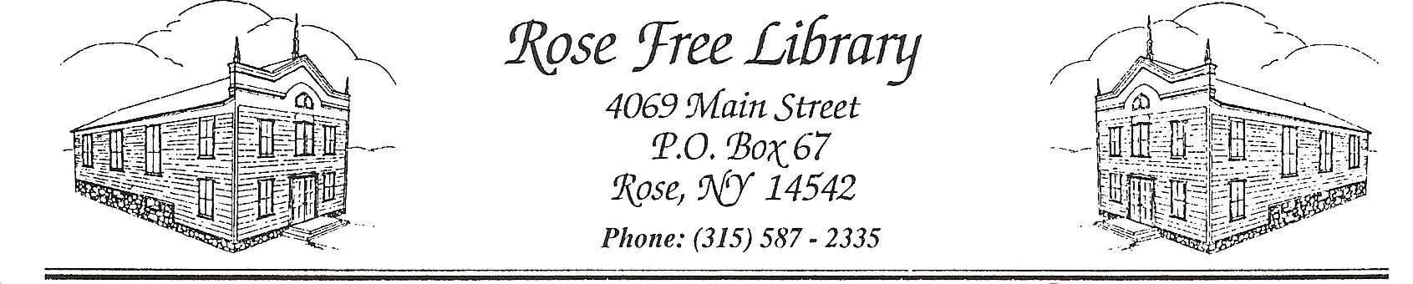
Rose Free Library

Records Retention and Removal

The purpose of the Records Retention and Removal policy is to ensure the proper management of Library records according to law and recommended practice.
- Confidentiality
Chapter 112, Laws of 1988, provides that any library records that personally identify users of libraries shall be confidential. Any questions regarding access to these records should be directed to the NYS Committee of Open Government.

- Business Records and Documents
The Sarbanes-Oxley Act addresses the destruction of business records and documents and turns intentional documents destruction into a process that must be carefully monitored. While public libraries currently are not under Sarbanes-Oxley, the law provides guidance on minimum retention requirements.
- Retention Period of Records

Retention Period Items Retained
Permanently | Audit reports; bylaws and charter; chartering and registration records; checks for important payments or purchases; contracts; current library policies; accident reports; deeds; deeds of gift; depreciation schedules; incorporation; insurance records; legal correspondence; manuscript or published catalog of holdings; Board of Trustee meeting minutes; mortgages and bills of sale; notes and leases; patents and related papers; retirement and pension records; tax returns and worksheets; trademark registrations and copyrights; yearend financials; all paper copies of the aforementioned
7 Years | Accounts payable ledgers and schedules; expense analyses and distribution schedules; expired contracts; expired mortgages, notes and leases; inventories of products, materials, and supplies; invoices (to customers and from vendors); memorial and donation records; payroll records and summaries; personnel files (terminated employees); timesheets; withholding tax statements; past Library policies
6 Years | Library material censorship and complaint records (including evaluations by staff, patrons’ complaints and record of final decision)
3 Years | Bank statements; employment applications; expired insurance policies; internal audit reports
2 Years | Bank reconciliation; correspondence with customers and vendors; duplicate deposit slips; general correspondence
1 Year | Accession records; individual title purchase requisitions which have been filled or are unable to be filled
Until superseded or obsolete | Borrowing or loaning records including interlibrary loan; directory of public library system and member libraries; records documenting selection of books and other library materials; library blueprints

- Digitization
The Library digitizes certain organizational records as a strategy for saving space, increasing access, reducing retrieval time, or creating back-ups. In such instances, the Library will ensure that the digitized images will accurately and completely reproduce all the information in the records being imaged and will not be rendered unusable due to changing or proprietary technology before their retention and preservation requirements are met.

Digitized items will be retained in accordance with the terms noted in Section 3 and in consideration of appropriate confidentiality and copyright standards.

Adopted by the Board of Trustees: 10/19/2020

