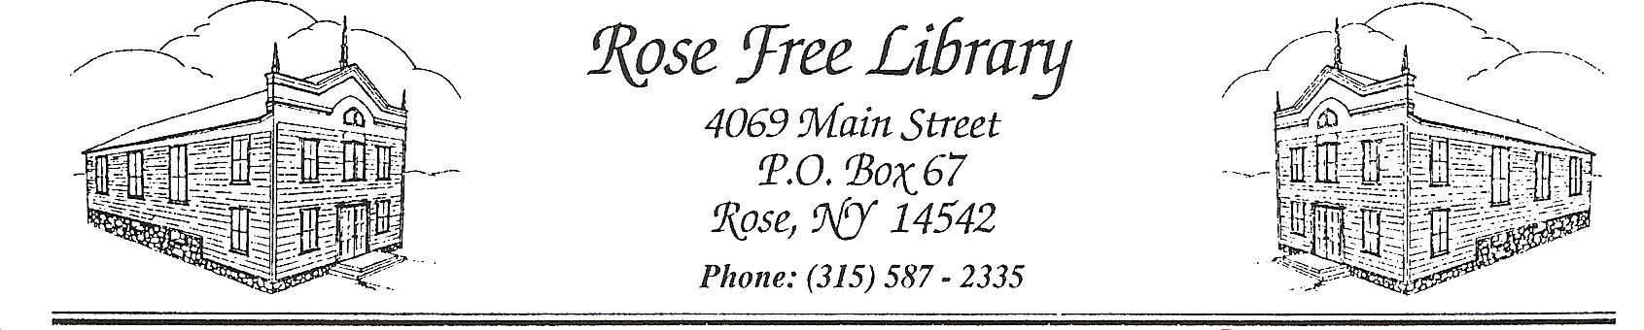
Rose Free Library
Technology Disaster Recovery Plan Policy
The Rose Free Library recognizes the importance of technology to Library operations and has developed a technology disaster recovery plan to ensure that in the event of an emergency or disaster, the Library will minimize the loss of data and/or threat to security.
Recovery Team
The Library will be responsible for executing the various aspects of this plan in an effort to minimize data loss from a disaster impacting the Library. The team will include the Director, the Board President, and the Computer Network Services Department of the Pioneer Library System.
Disaster Communication
In the event of an emergency or disaster at the Library, the first person on scene will contact the appropriate emergency service and then the Director. The Director is responsible for notifying the Library Board President and the Pioneer Library System.
Data Recovery Strategy
The Pioneer Library System has configured a daily backup of all individual staff computers as well as the Reference Desk computer using the Apple iCloud storage system. The Pioneer Library System administers an integrated library system (ILS) and supports the Library by maintaining computer databases of the libraries’ inventory of materials available for loan, library patron borrowing and account histories, and staff email. ILS servers are located at 2557 State Route 21, Canandaigua, NY.
Hardware
The Library and the Pioneer Library System maintain an inventory of Library computers. The inventories will be used by the Recovery Team to evaluate recovered devices depending on the disaster and to prioritize purchases for replacement equipment.

Adopted by the Board of Trustees: 9/14/20

