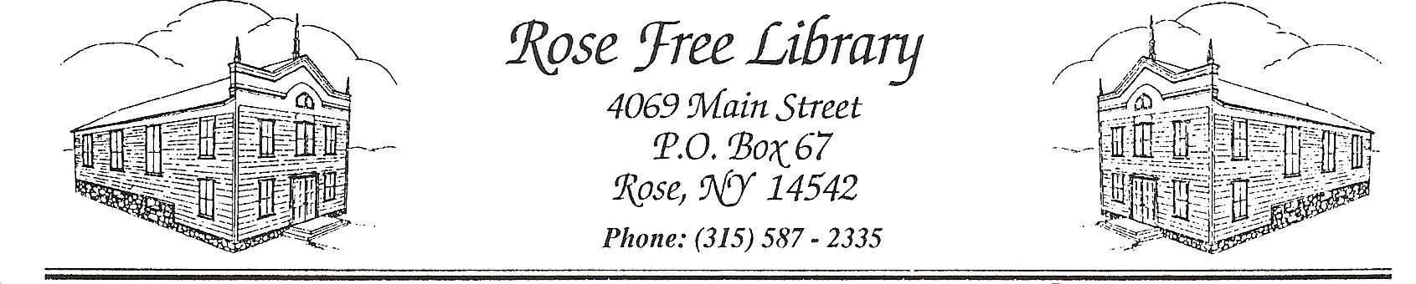
Requests for Confidential Library Records
The Rose Free Library adheres to New York Civil Practice Law and Rules section 4509: Library circulation records. This law, enacted in 1988, protects the confidentiality of library records of users. It includes but is not limited to, “records related to the circulation of library materials, computer database searches, interlibrary loan transactions, reference queries, requests for photocopies of library materials, title reserve requests, or the use of audiovisual materials, films or records.”
Library staff are aware that such records are confidential, and are not to be made available to any agency except under due process of law, and then only upon the advice of the Library’s legal counsel and the Pioneer Library System.

Adopted by the Board of Trustees: 9/14/2020

