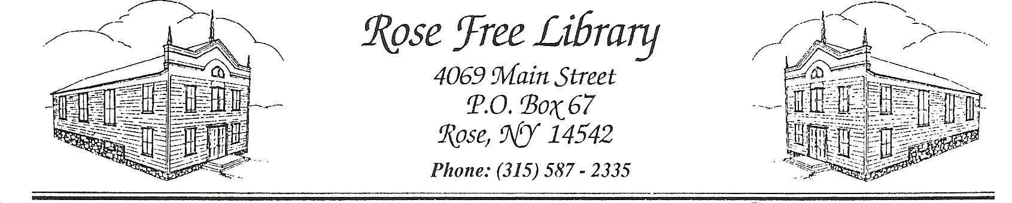
Open Meetings Policy
In accordance with New York State’s Open Meetings Law, as well as Education Law Title 1, Article 5, Section 260a, the Rose Free Library (“the Library”) opens their Board of Trustee meetings to the general public. Closed, or executive, sessions may be called as a portion of the open meeting and appropriate business transacted therein.
The minutes of the open meeting and of the executive session are compiled on the Library’s website and are also available upon request. The minutes of the open meeting consist of a record or summary of all motions, proposals, resolutions and any matter formally voted upon and the resulting vote. Minutes of an executive session consist of a record or summary of the final determination of any action taken and the resulting vote.
The calendar of regular Board of Trustees meetings is voted on by the Board of Trustees at their annual meeting in July. Meetings are typically scheduled for the 2nd Monday of each month, and held in the Library’s Community Room beginning at 6:30pm. Notice of the time and place of each meeting is given to the public at least one week in advance of the meeting.
Online Meetings
In instances where it is not safe or possible to meet in person. and as permissible by law or executive order of New York State, the Library’s Board of Trustees will meet online or reschedule in such cases, the online meetings will be open to the public and the meeting information will be shared via the Library’s event calendar.

Adopted by the Board of Trustees:

